

How to use Batches
A step-by-step guide for warehouse staff, managers and admins
━━━━━━

Ladles of Love · Batches warehouse system
For everyone who works in the warehouse
October 2026

Contents
Contents 2
1. Start here 3
2. Signing in and finding your way 4
2.1 Sign in 4
2.2 Volunteers: sign in as a guest 5
2.3 The parts every screen has 6
3. On the warehouse floor 7
3.1 Receiving a delivery 8
3.2 Packing a pallet 9
3.3 Decanting bulk food 10
3.4 Dispatch: handing pallets to drivers 10
3.5 Recording a donation 11
4. Managers 12
4.1 Your dashboard 12
4.2 Ordering from a supplier 13
4.3 Picking slips: what each centre gets 15
4.4 Stock 16
4.5 Reports 17
5. Admins 18
5.1 People 18
5.2 Settings 19
6. Quick answers 20

1. Start here
Batches is the Ladles of Love warehouse system. It records food coming in, packs it for the centres we feed, and sends it out. Everyone signs in at the same address and sees only the screens for their job.
You are | You use Batches to | Go to
Warehouse staff | Receive deliveries, pack pallets, decant bulk food, hand pallets to drivers, record donations | Section 3
Manager | Order from suppliers, watch stock, make picking slips, follow up problems, see reports | Section 4
Admin | Add people, products and suppliers, and change settings | Section 5
Volunteer (guest) | Pack one pallet, with no account | Section 2.2

How to read this guide
Each picture has red numbered boxes. The numbered steps next to or under the picture match them.
The names and numbers in the pictures are examples, not real records.

2. Signing in and finding your way

2.1 Sign in
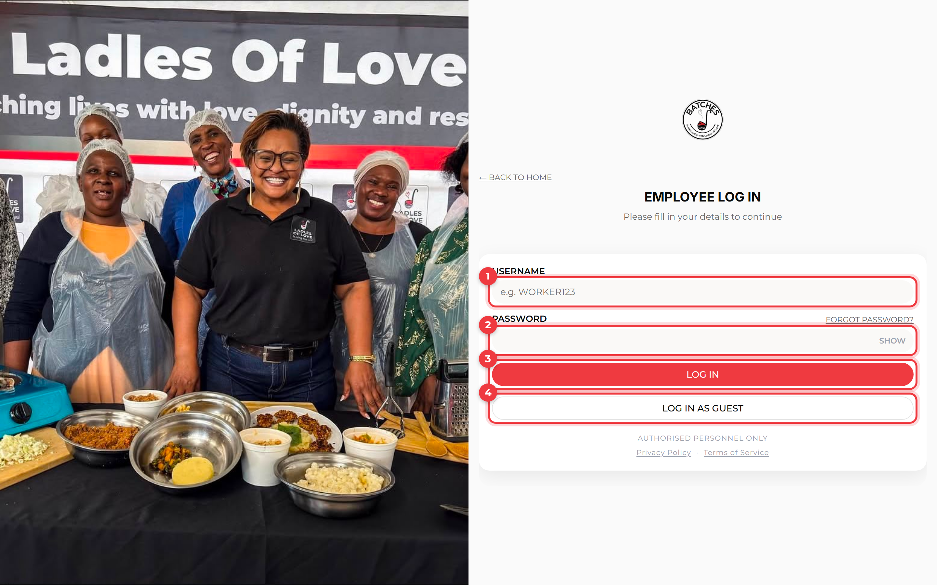
The sign-in page
1 | Type your username. Your admin gives it to you, or you chose it when you accepted your invite email.
2 | Type your password. Tap Show to check what you typed. Forgot it? Tap Forgot password? and follow the email.
3 | Tap Log in. You go straight to your own home screen.
4 | Log in as guest is for volunteers without an account (see 2.2).

Good to know
You stay signed in for 8 hours. On a shared tablet, sign out when you finish (name menu, then Log out).

2.2 Volunteers: sign in as a guest
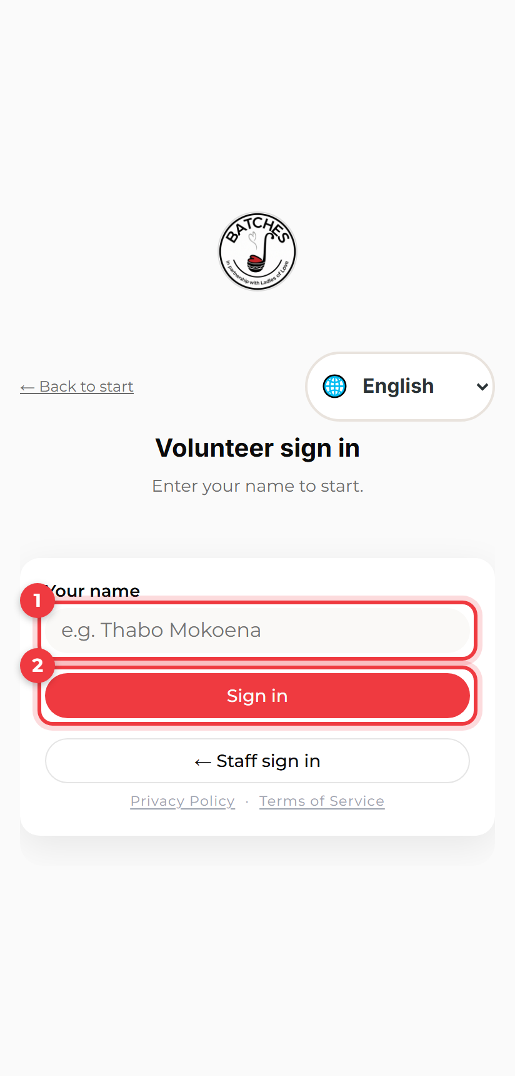  Volunteer sign in | No account needed  1 Type your name. It goes on the pallet you pack, so the warehouse knows who helped.  2 Tap Sign in. Then scan the QR code on a pallet, or type the short code a staff member gives you.  Tip Pick your language at the top: English, Afrikaans or isiXhosa.

2.3 The parts every screen has
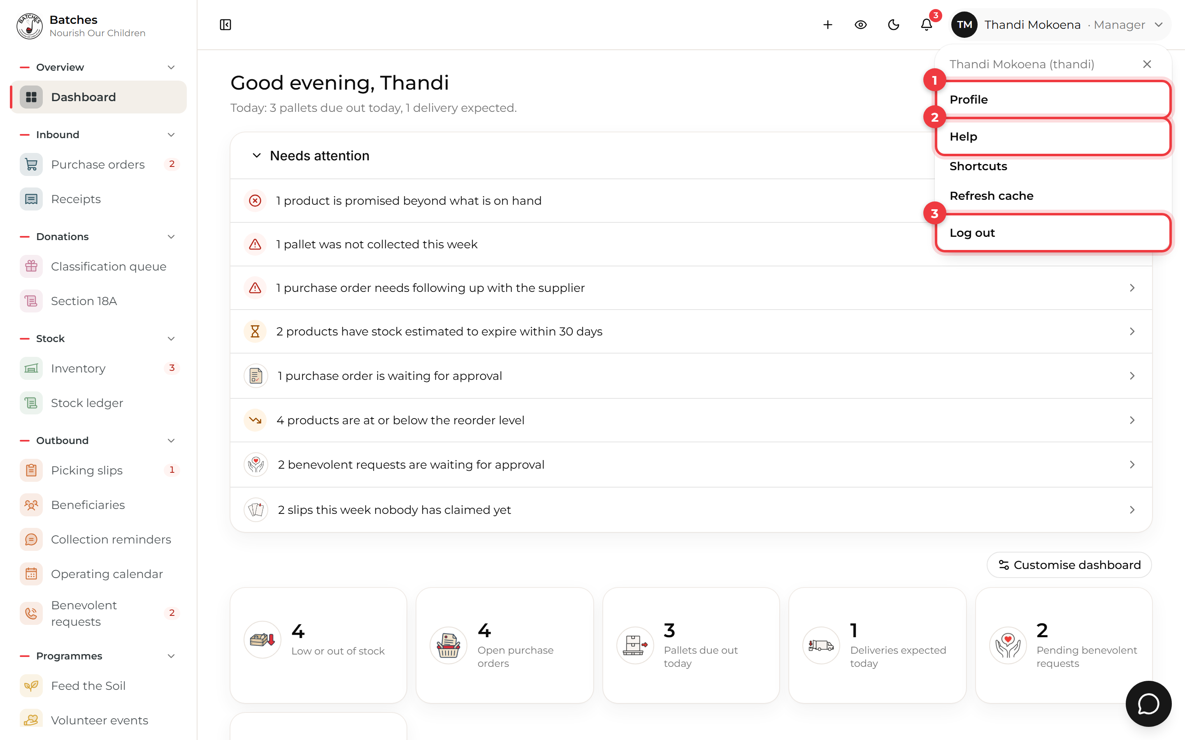
The name menu, top right
1 | Profile: see your details, and change your email or password. You need your current password to do it.
2 | Help: short answers about the screen you are on. The round chat button at the bottom right answers questions in your own words.
3 | Log out.

- The bell shows new notifications, such as a new picking slip or a product running out. See all notifications opens the full list.
- No signal? Keep working. What you save waits on the phone and sends itself when the signal comes back. A bar at the top says what is waiting. Claiming or releasing a pallet is the one thing that needs a signal.
- Guided or Form Floor screens offer Guided (one thing at a time) or Form (everything on one page). Both do the same job. Pick the one you like; the screen remembers.

3. On the warehouse floor
These screens are made for a phone or tablet. The bar along the bottom takes you between the jobs.
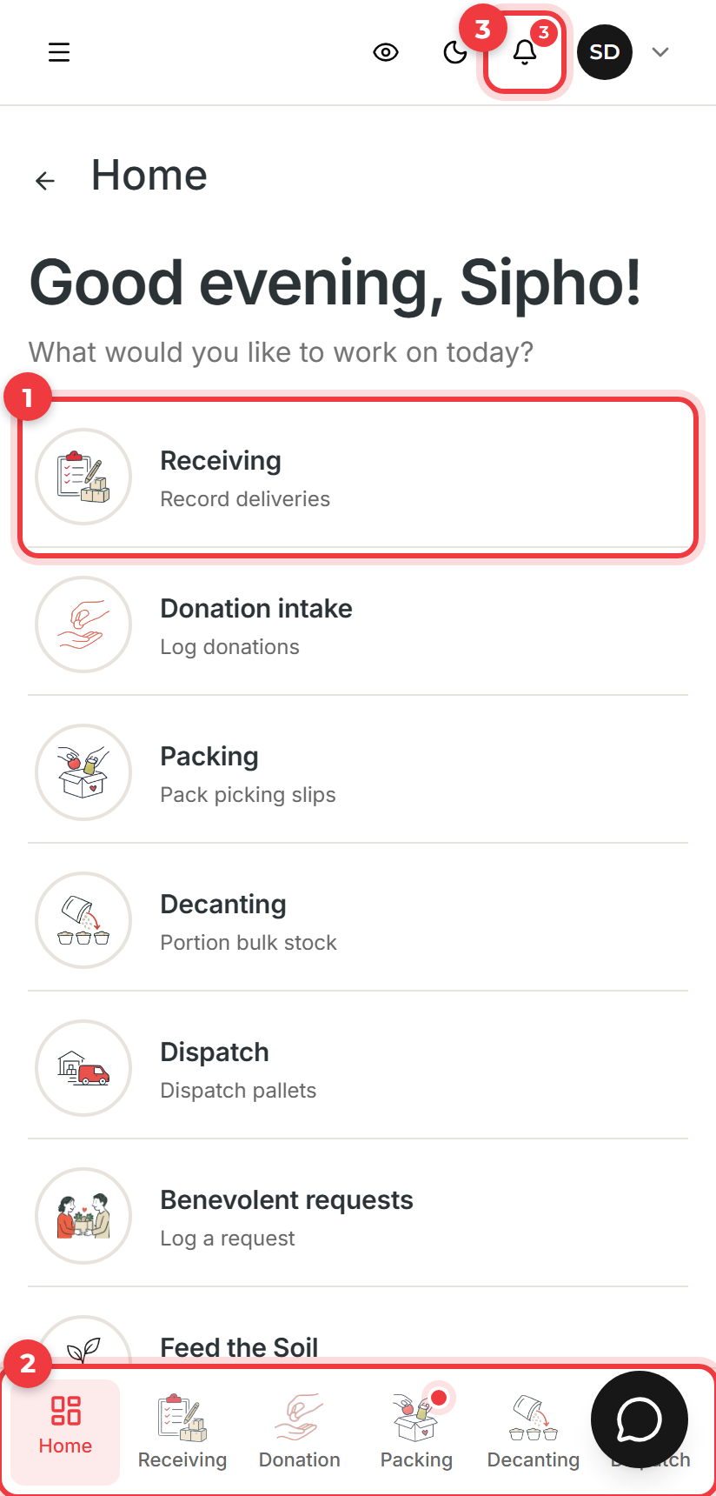  Your home screen | Your home screen  1 Tap a job to start it. Each one walks you through in a few steps.  2 The bottom bar is always there. A red dot means something new, for example a pallet waiting to be packed.  3 The bell shows your notifications.  Tip Choose your language from your home screen. It follows you to any tablet you sign in on.

3.1 Receiving a delivery
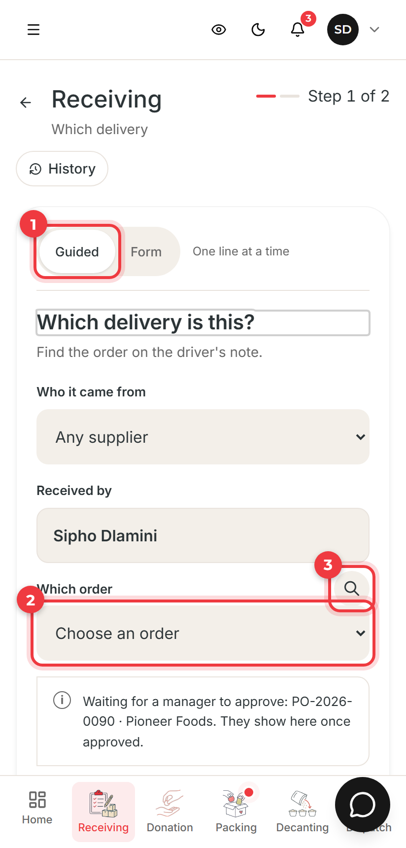  Step 1: which delivery | Step 1: find the order  1 Choose Guided to count one line at a time, or Form to see every line at once.  2 Choose the order from the driver's note. Picking the supplier first makes the list shorter.  3 Or tap search and type the order number, supplier or date. Then tap Start counting.  Tip Only approved orders appear. One still waiting for a manager is named under the list so you know why.

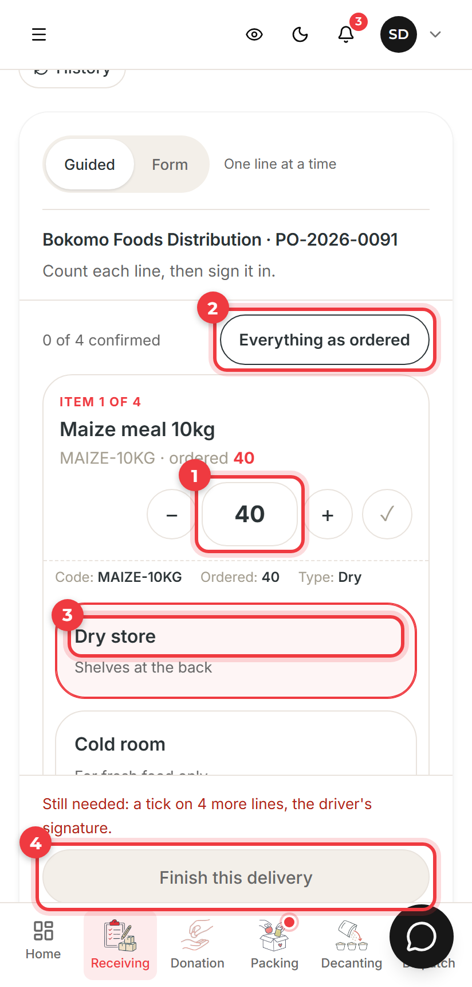  Step 2: count and put away | Step 2: count every line  1 Type how many arrived, or use – and +. Tap the tick when the line is right.  2 If everything matches the order, Everything as ordered fills in every line for you.  3 Choose where it goes (dry store or cold room) and type the date on the box. Fresh food must have one.  4 Ask the driver to sign, then tap Finish this delivery. You can download the delivery note.  Tip If a line is short, save it anyway. Your manager is told and follows it up with the supplier.

3.2 Packing a pallet
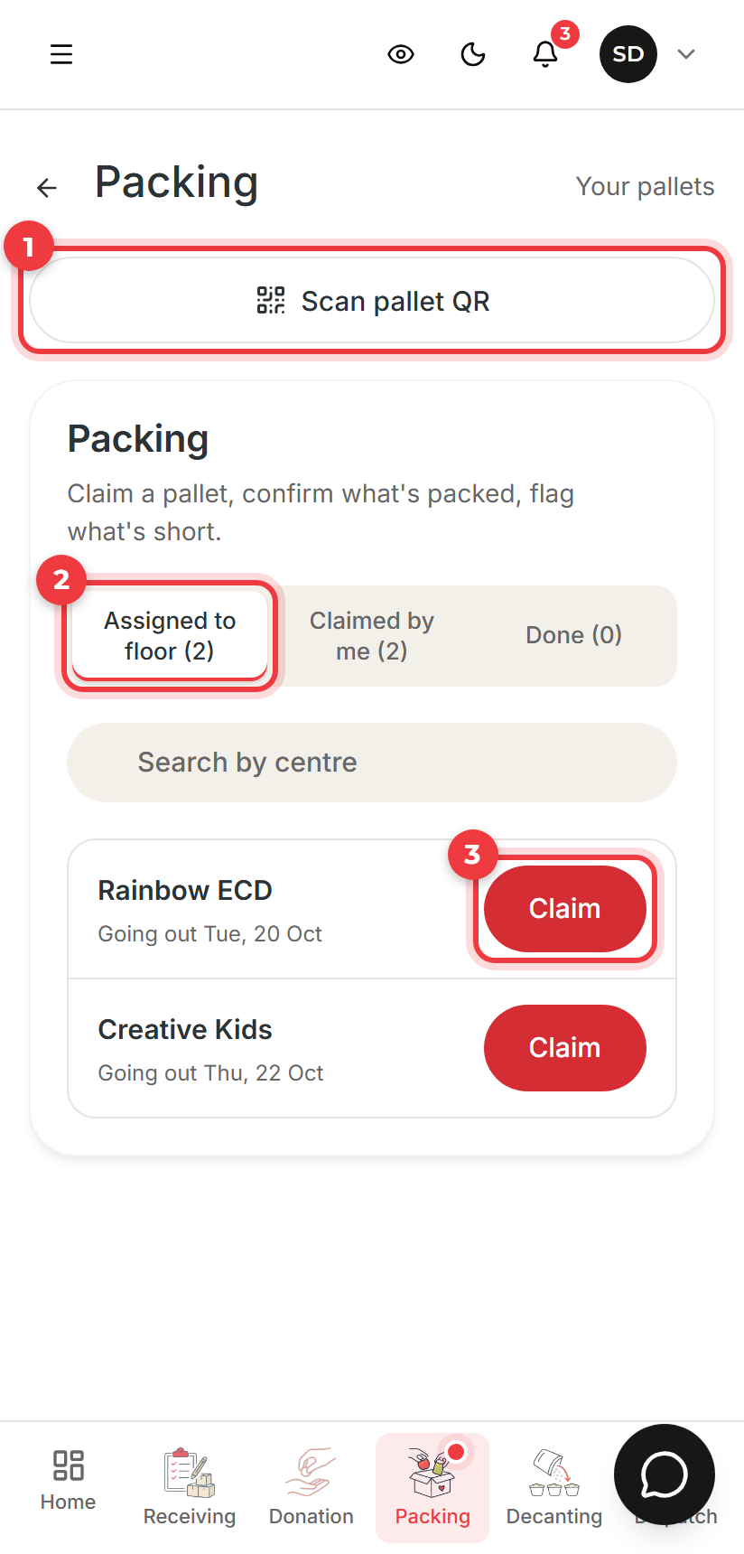  Your pallets | Claim a pallet  1 Scan pallet QR opens a pallet straight from its label.  2 Assigned to floor lists pallets nobody has taken yet. Claimed by me is your own list.  3 Tap Claim to take a pallet. It moves to your list and nobody else can pack it.

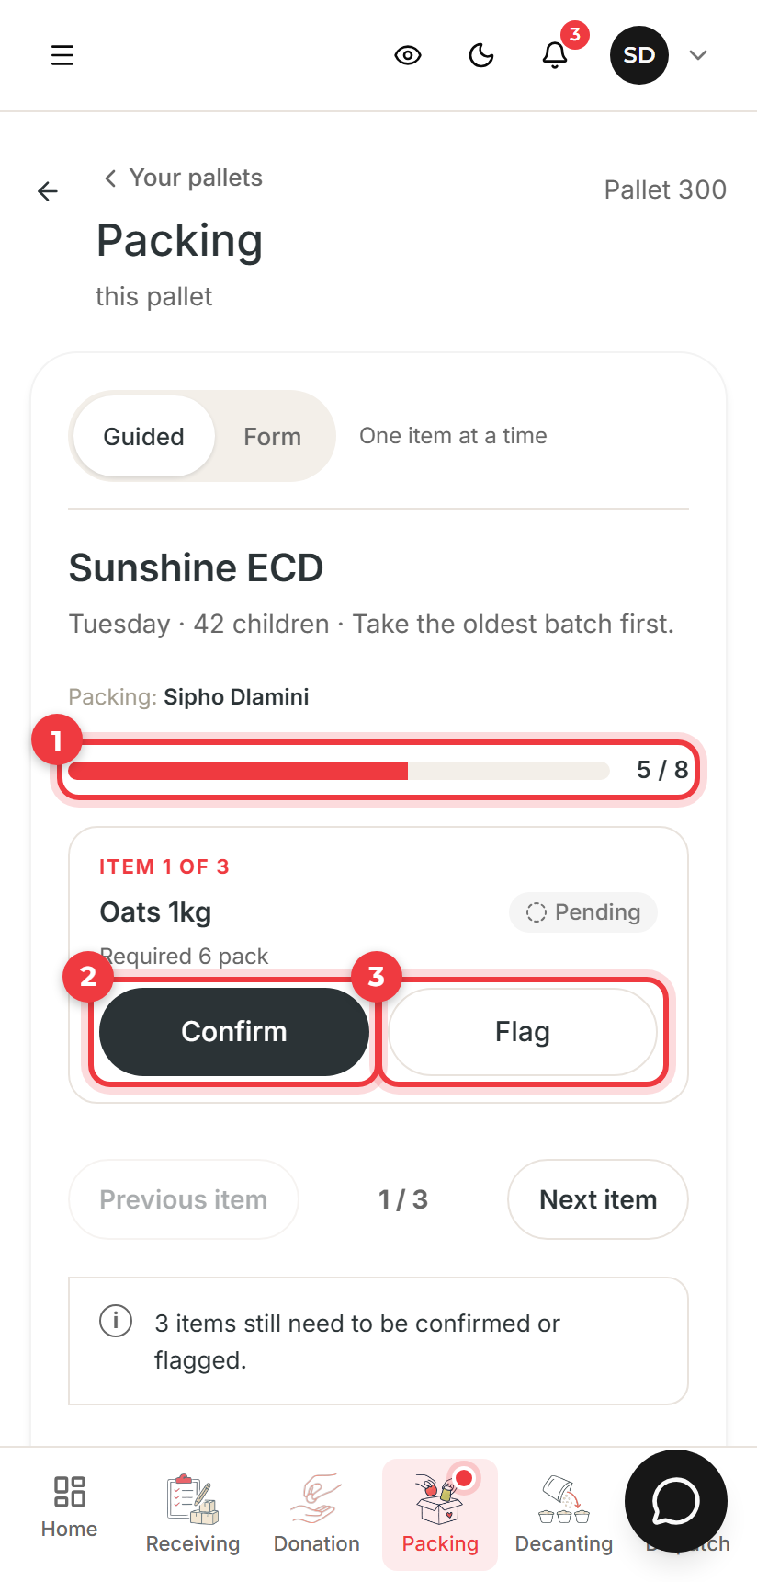  Packing one pallet | Pack each item  1 The bar shows how much of the pallet is done.  2 Packed the right amount? Tap Confirm.  3 Something short, damaged or missing? Tap Flag, choose why, and take a photo. The manager sees it on the slip.  Tip Take the oldest stock first. When every item is confirmed or flagged, finish the pallet and it shows at the gate.

3.3 Decanting bulk food
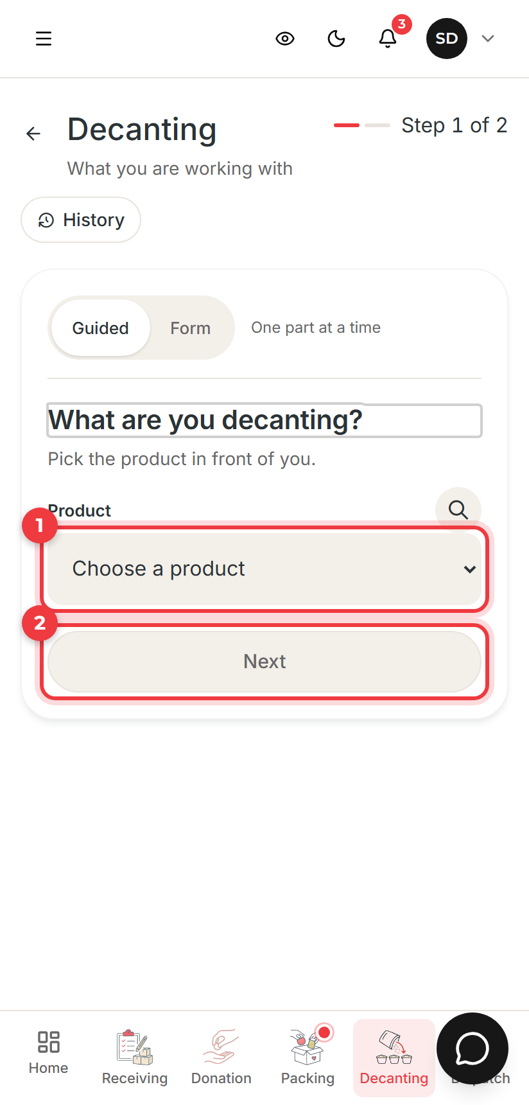  Decanting | Weigh, bag and count back  1 Choose the product in front of you (for example a bulk sack of rice).  2 Tap Next. Weigh the bulk amount. Batches works out how many bags of each size to make.  Tip Count what you actually bagged and record anything spilled, then save. The decanting sheet is kept under History.

3.4 Dispatch: handing pallets to drivers
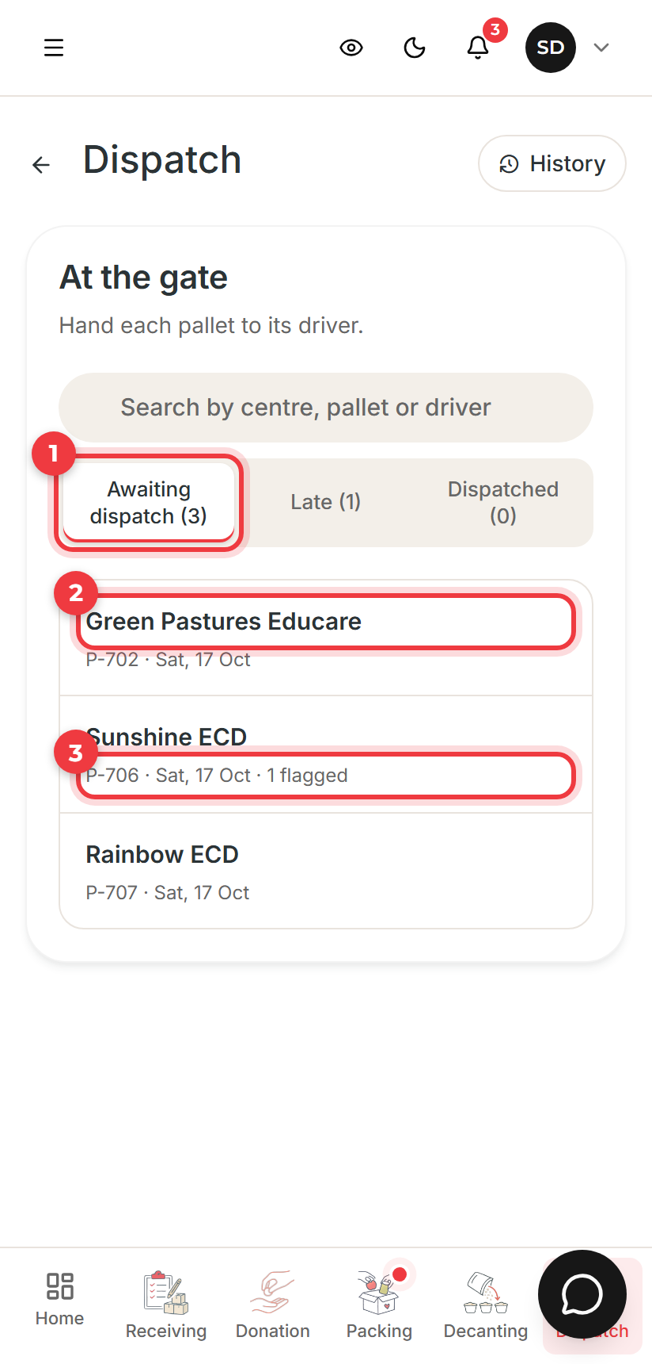  At the gate | At the gate  1 Awaiting dispatch is today's pallets. Late is any not collected on their day.  2 Tap the centre whose driver is in front of you. Check the pallet, take the driver's name and signature, and confirm.  3 1 flagged means the packer flagged an item. Check it before it goes.  Tip Stock comes off the books here, when the pallet leaves, not when it is packed.

3.5 Recording a donation
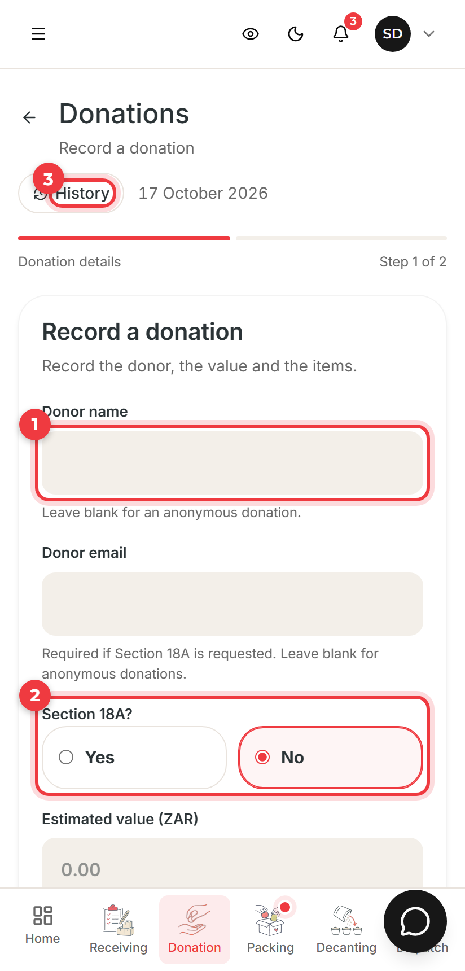  Record a donation | Record the donor, then the items  1 The donor's name. Leave it blank for an anonymous donation.  2 Section 18A? Choose Yes if the donor wants a tax certificate. Their email is then needed.  3 History shows the donations you recorded and where each has got to.  Tip On the next step add each item. If a product is not in the list, describe it: a manager sorts it out in the Classification queue.

4. Managers

4.1 Your dashboard
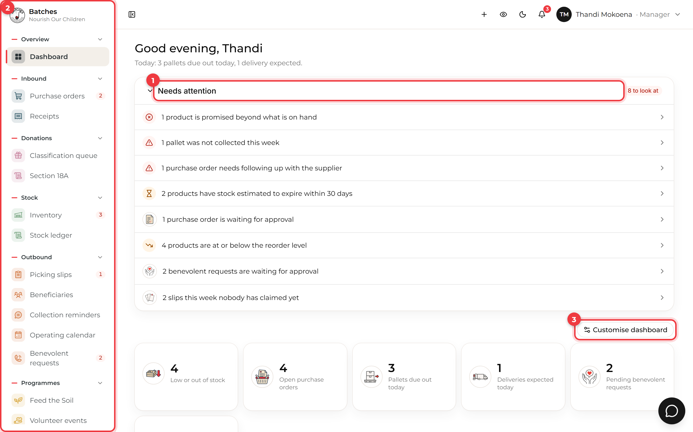
The manager dashboard
1 | Needs attention lists what needs you today. Click a line to open exactly those records.
2 | The side menu is grouped by job (Inbound, Stock, Outbound and so on). A red number shows how many things wait inside. Click a heading to fold it away.
3 | Customise dashboard chooses which tiles and charts you see.

4.2 Ordering from a supplier
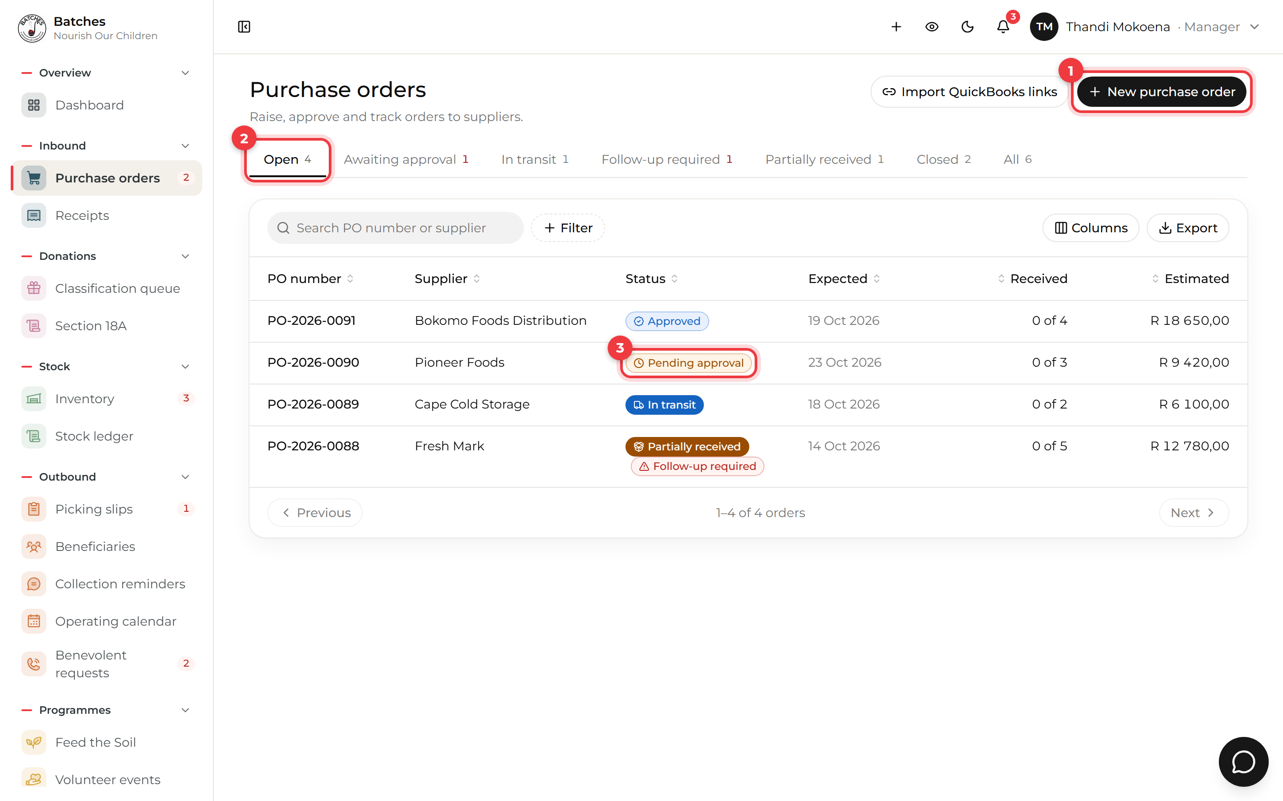
Purchase orders
1 | New purchase order starts an order.
2 | The tabs sort orders by where they are: open, awaiting approval, in transit, follow-up required and so on.
3 | An order pending approval needs a manager to open it and approve it. Approved orders are emailed to Finance and appear on the floor for receiving.

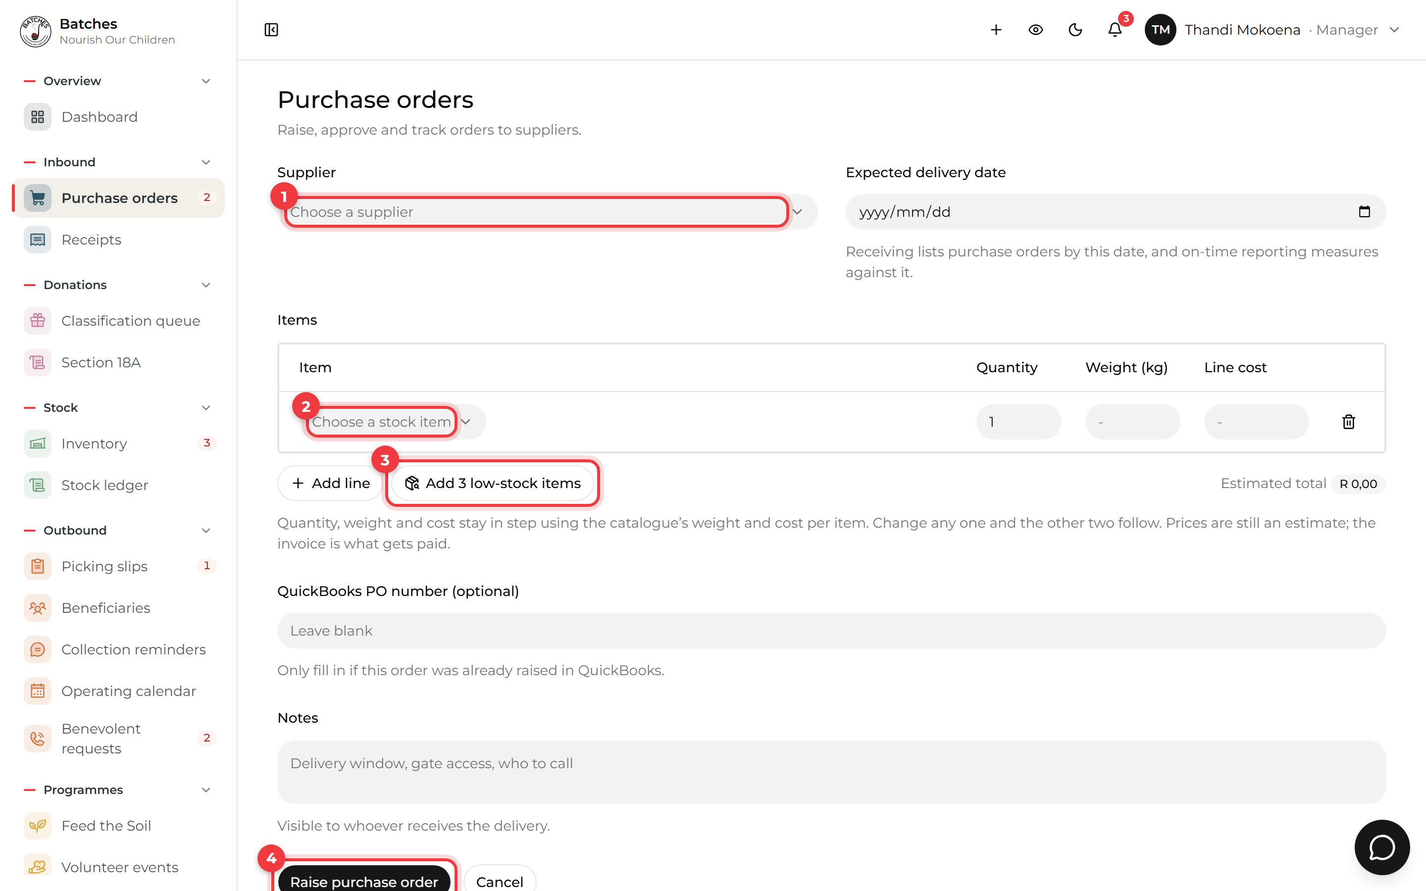
A new purchase order
1 | Choose the supplier and the expected delivery date.
2 | Add each item and its quantity. Weight and cost fill themselves in from the product list.
3 | Add low-stock items adds everything at or below its reorder level in one click.
4 | Raise purchase order. It then waits for approval.

4.3 Picking slips: what each centre gets
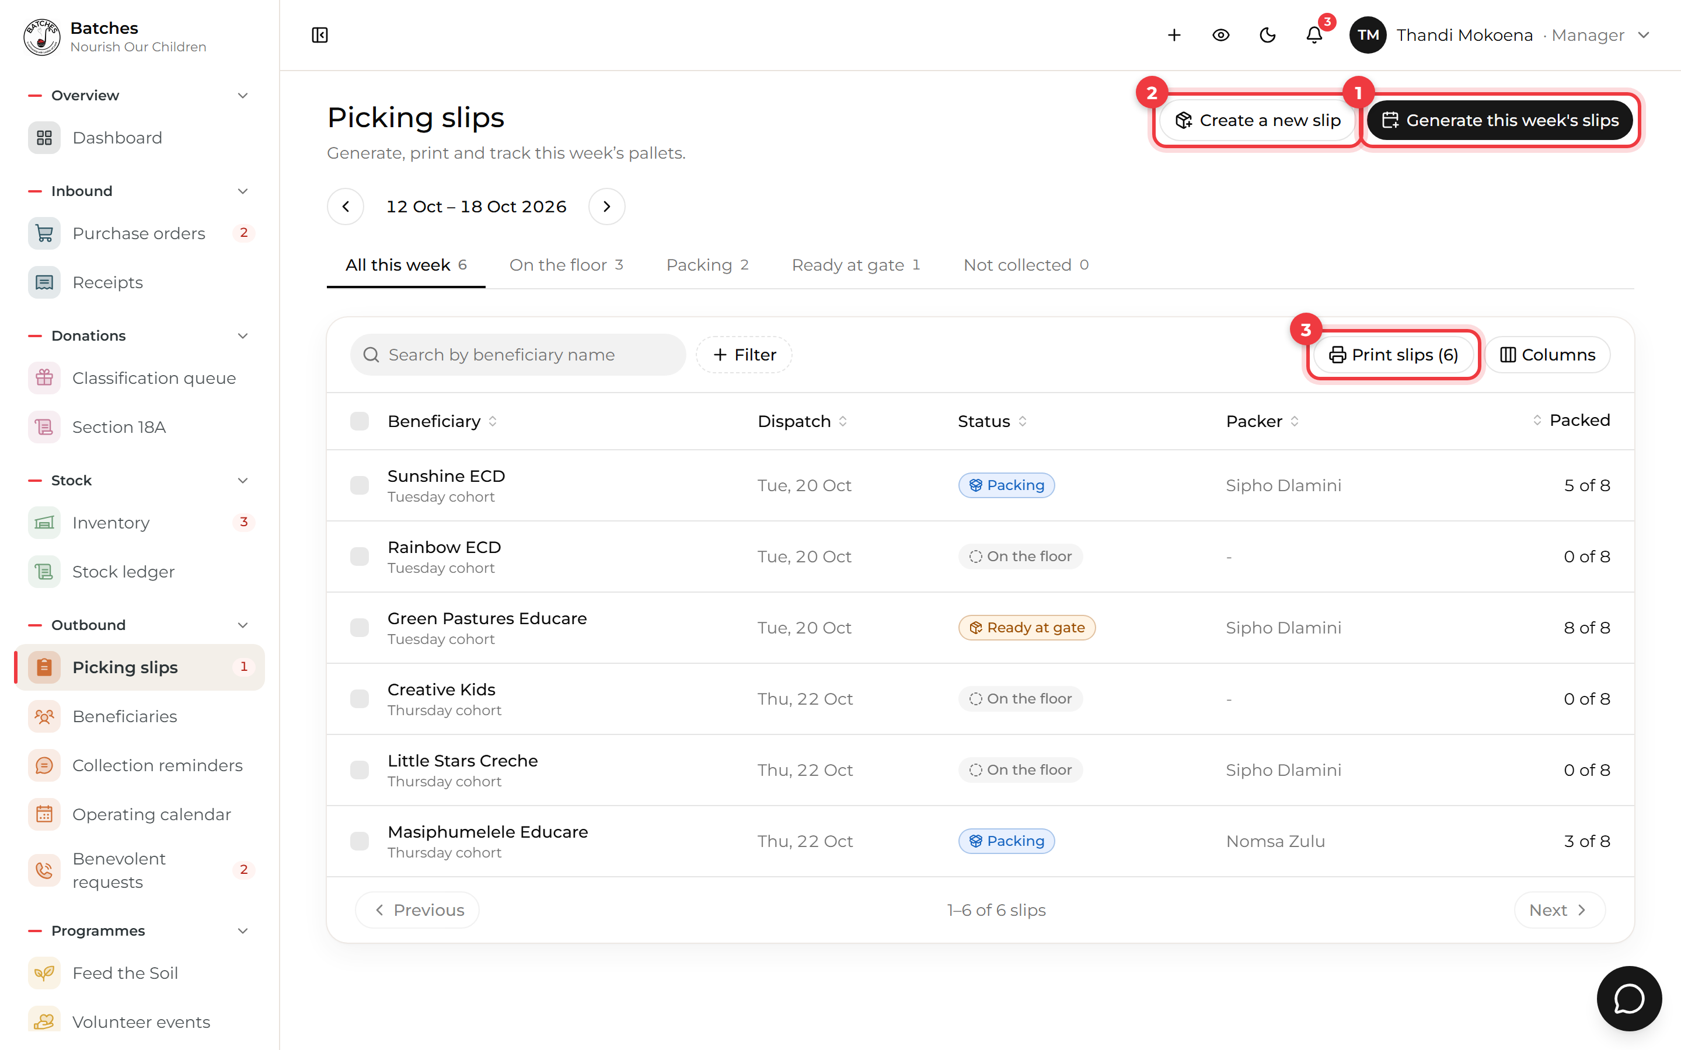
Picking slips for the week
1 | Generate this week's slips makes a slip for every centre in a cohort (Tuesday or Thursday), using the recipe in use, or each centre's standing order.
2 | Create a new slip makes one slip by hand, for example for a soup kitchen or a late centre.
3 | Print slips prints the selected slips with their QR codes for the floor.

Before you generate
Check the recipe in Settings > Recipes and each centre's child count under Beneficiaries. The quantities come from them.

4.4 Stock
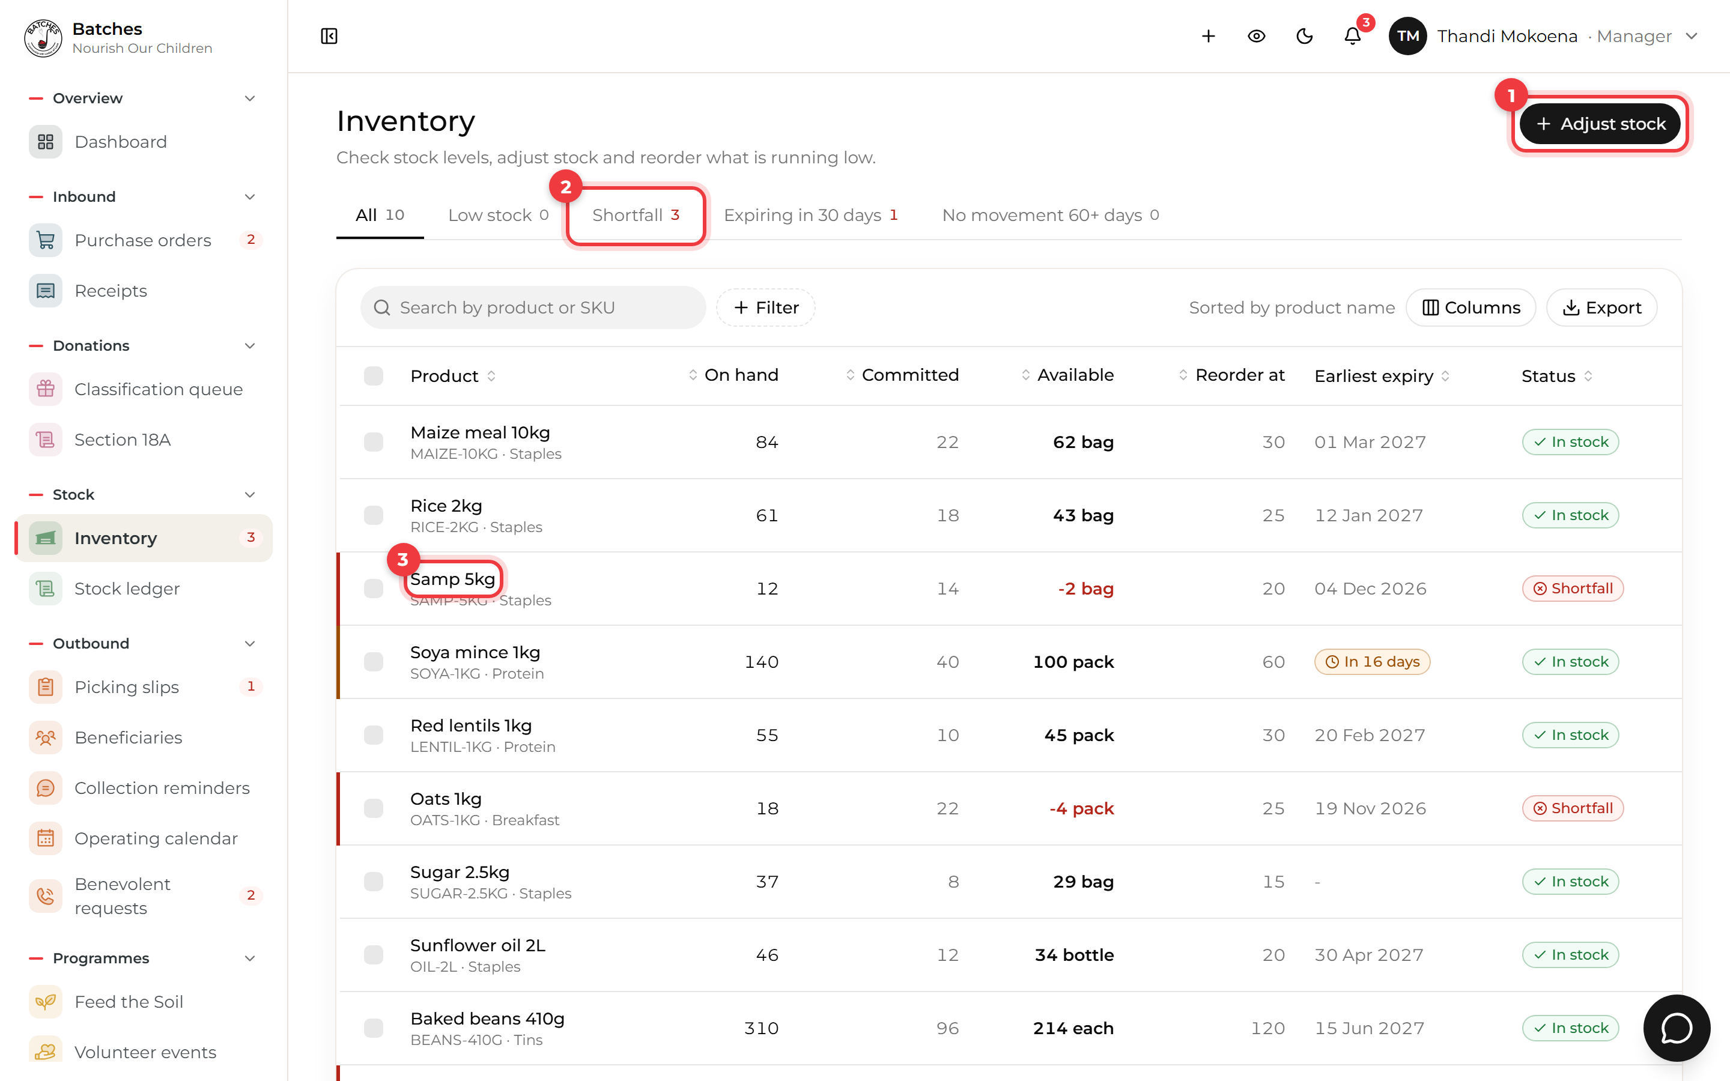
Inventory
1 | Adjust stock corrects a count, for example after the Friday stock take. Every change is kept in the Stock ledger with your name and reason.
2 | Shortfall lists products promised to slips beyond what is on the shelf. Order these first.
3 | A red edge marks a product short of stock; an orange date marks stock close to expiry. Click a row to see its deliveries and history.

On hand is on the shelf. Committed is packed or promised to a slip. Available is what is left to promise.

4.5 Reports
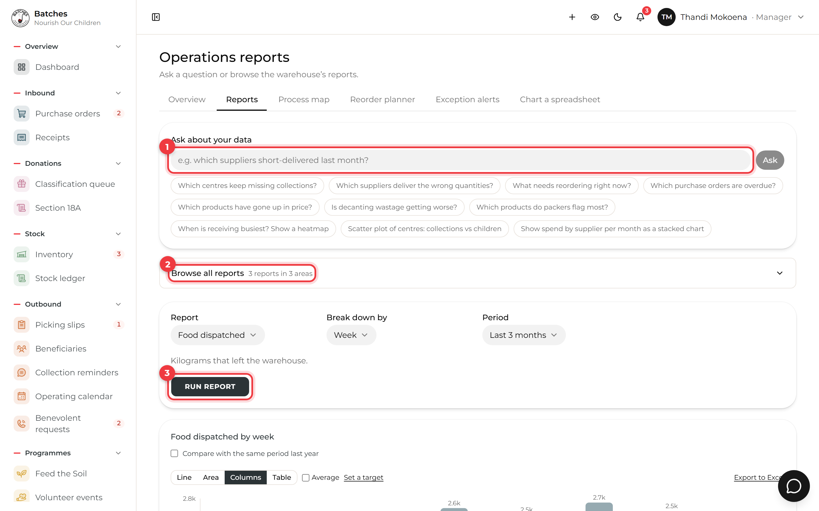
Operations reports
1 | Ask about your data in plain words, or tap one of the example questions.
2 | Browse all reports lists every report the system has, by area.
3 | Or choose a report, how to break it down and the period, then Run report. Charts can be saved, exported to Excel, or emailed on a schedule.

- Classification queue is where you sort donated items the system did not recognise.
- Benevolent requests, Feed the Soil, Volunteer events each have their own screen in the side menu and work the same way: a list, tabs across the top, and a panel when you click a row.

5. Admins

5.1 People
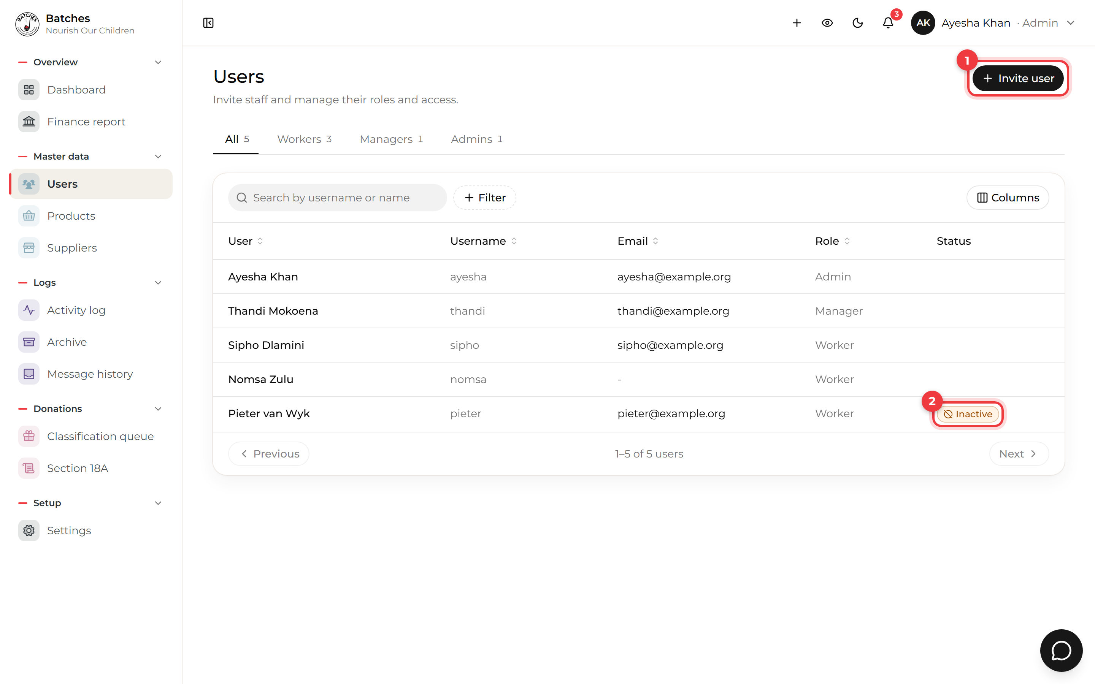
Users
1 | Invite user: type their name, email and role. They get an email with a link to choose a username and password.
2 | Someone leaving? Open them and deactivate the account. It is never deleted, so their past work still shows who did it.

5.2 Settings
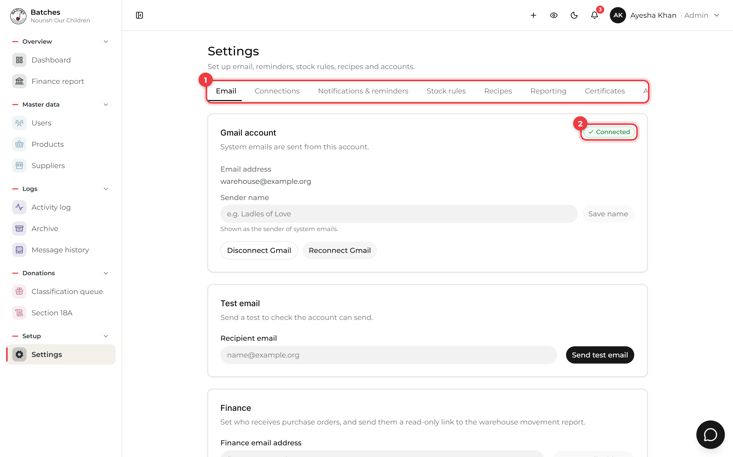
Settings
1 | The tabs: Email, Connections, Notifications & reminders, Stock rules, Recipes, Reporting and Certificates.
2 | Connected shows the Gmail account system emails are sent from. Connections shows whether email, AI, phone alerts and QuickBooks are working.

Setting | What it changes
Stock rules | What a crate, bag, box and punnet weigh, and the two expiry warnings
Notifications & reminders | When centres are reminded to collect, and the not-collected cut-off
Recipes | The menu picking slips are made from, and children per band
Certificates | The organisation details printed on Section 18A certificates

Products and suppliers are added and edited under Master data in the side menu. The Activity log shows who changed what.

6. Quick answers
Problem | What to do
I forgot my password | Tap Forgot password? on the sign-in page. The link in the email works once, for one hour.
A screen says there is no signal | Carry on. Saved work waits on the phone and sends itself later.
I cannot see a screen a colleague can | Screens depend on your role. Ask an admin if your role is wrong.
The order I need is not in Receiving | It may still be waiting for approval. Ask a manager to approve it.
I made a mistake in a count | A manager can correct stock in Inventory with Adjust stock. The change is recorded with a reason.
The app looks out of date | Name menu > Refresh cache, or close and reopen the page.
Something else | Use Help in the name menu, or ask the chat button at the bottom right.

